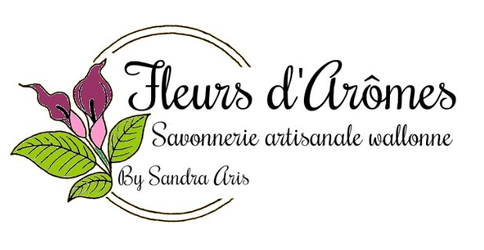
CERTIFICAT ALLERGENES
FRAGRANCE : Tarte Citron Meringuée

CAS | INCI NAME | CONCENTRATION
 |  | (% W/W)
127-51-5 | Alpha-Isomethyl Ionone (Gamma Methyl Ionone)
122-40-7 | Amyl Cinnamal (Alpha Amyl Cinnamic Ald)
101-85-9 | Amylcinnamyl Alcohol (Alpha Amyl Cinnamic Alcohol)
105-13-5 | Anisyl Alcohol(Anisic Alcohol)
100-51-6 | Benzyl Alcohol
120-51-4 | Benzyl Benzoate | 39.995
103-41-3 | Benzyl Cinnamate
118-58-1 | Benzyl Salicylate
104-54-1 | Cinnamyl Alcoho
104-55-2 | Cinnamal (Cinnamic Aldehyde)
5392-40-5 | Citral | 10.000
106-22-9 | Citronellol | 0.200
91-64-5 | Coumarin
97-53-0 | Eugenol
4602-84-0 | Farnesol
106-24-1 | Geraniol | 0.200
101-86-0 | Hexyl Cinnamal (Hexyl Cinnamic Ald)
107-75-5 | Hydroxycitronellal
97-54-1 | Isoeugenol
80-54-6 | Butylphenyl Methylpropional (Lilial)
31906-04-4 | Hydroxyisohexyl-3-cyclohexene Carboxaldehyde(Lyral)
5989-27-5 | Limonene (Orange Terpenes) | 8.000
78-70-6 | Linalool | 2.000
111-12-6 | Methyl 2-Octynoate(Folione) - Methyl Heptine Carbonate
90028-68-5 | Evernia Prunastri extract(Treemoss)
90028-67-4 | Evernia Furfuraceae extract(Oakmoss)

